# Skills Enablement Game

## Game Plan

**UoB MSc Computer Science Summer Project**

*Hanyu Li, Yue Wang, Xufeng Yin, Kathy Zhang, Siru Zhang*

## Game Name

Skills Enablement Game: EduCity

## **Game Type**

A 4X (eXplore, eXpand, eXploit, eXterminate) strategy game

## **Game Mode**

A Multiplayer online web-side game

## **Game Prototype**

(This prototype is for reference only and only shows the initial idea of the project. The overall color scheme, UI, model/map, and functions will be gradually improved in the subsequent development, and may be very different from the prototype.)

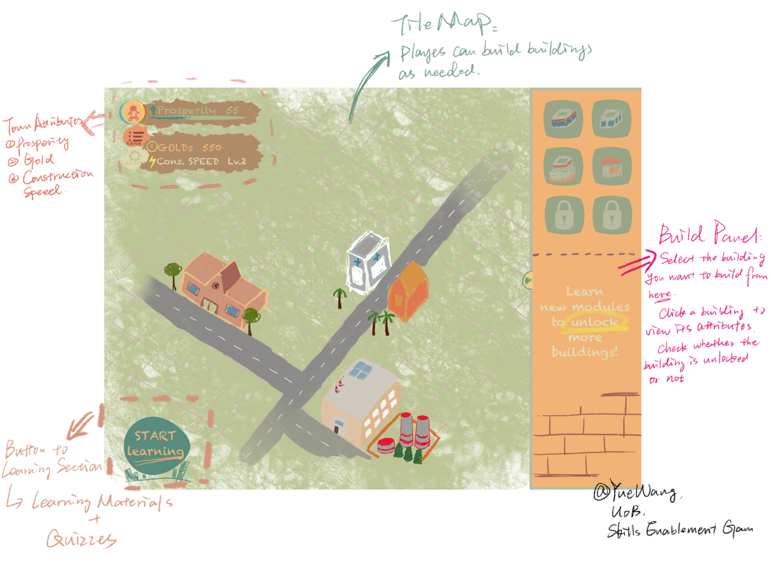

## **Gameplay and Mechanics**

### Game Story Background

In a future world of highly advanced technology, human societies are faced with growing urbanization challenges and competition for resources. Against this backdrop, a group of scientists, engineers and urban planning experts have launched an unprecedented experimental project to explore the possibilities of building and managing cities through learning and technological innovation.

The story is set in a virtual city called "EduCity", which is located in the center of a region full of technological wonders. "EduCity" is known for its advanced technological facilities and unique architectural style, attracting people from all over the world to visit and settle in the city.

### **Core Mechanisms**

In this virtual world, each player takes on the role of a city builder who can enhance their city by completing a variety of learning experiences. These learning experiences represent different areas and skills, and each gives the city a unique "buff" that gives it a special ability or advantage in a particular area; for example, completing an engineering learning experience will allow the city to build construction sites to increase the speed of building construction.

As players continue to learn and develop, their cities will grow. Cities grow not only in terms of increasing population, but also in terms of improving the quantity and quality of buildings, improving infrastructure, and promoting technological innovation. Each player's decisions and learning direction will directly affect the trajectory and competitiveness of the city.

**- Town Attributes**

* **Prosperity:** An index to rank Players.
* **Gold:** The artificial currency in this game to construct houses.

How to get gold:

1) By quiz score. After players finish a learning module, they will be rewarded with gold based on their quiz scores. For example, a quiz with 100% correct answers awards 100 gold.

2) By special House. Some types of house can generate gold.

* **Construction Speed:** The time required to construct a house, ranging from level 1 to level 6.

The initial construction speed is 1, taking 24 hours to build each house and 12 hours to upgrade each house. For each level upgrade, construction time is reduced by 4 hours, and upgrade time is reduced by 2 hours. The maximum speed is 6, where it takes 4 hours to build each house and 2 hours to upgrade each house.

**- House Settings**

House types need to complete learning modules to unlock. Each house has 3 level, players can spend gold to upgrade house level to get more benefits.

**House Unlocking Condition:**

|  |  |
| --- | --- |
| **House Type** | **Unlocking Condition** |
| Residential Building | / |
| Bank | Finish learning module of Data Science |
| Supermarket | Finish learning module of Security |
| Park | Finish learning module of Cloud |
| Farm | Finish learning module of AI |
| Construction Site | Finish learning module of Engineering |

**House Construction Fee:**

|  |  |  |  |
| --- | --- | --- | --- |
| **House Type** | **Level 1** | **Level 2 (upgrade fee)** | **Level 3 (upgrade fee)** |
| Residential Building | 300 gold | 150 gold | 225 gold |
| Bank | 800 gold | 400 gold | 600 gold |
| Supermarket | 300 gold | 150 gold | 225 gold |
| Park | 200 gold | 100 gold | 150 gold |
| Farm | 200 gold | 100 gold | 150 gold |
| Construction Site | 300 gold | 150 gold | 225 gold |

**House Attributes:**

|  |  |  |  |
| --- | --- | --- | --- |
| **House Type** | **Level 1** | **Level 2** | **Level 3** |
| Residential Building | Prosperity +5 | Prosperity +10 | Prosperity +20 |
| Bank | Prosperity +5  +300 gold per day | Prosperity +10  +600 gold per day | Prosperity +20  +1200 gold per day |
| Supermarket | Prosperity +2  +100 gold per day | Prosperity +4  +200 gold per day | Prosperity +8  +400 gold per day |
| Park | Prosperity +3 | Prosperity +6 | Prosperity +12 |
| Farm | Prosperity +3 | Prosperity +6 | Prosperity +12 |
| Construction Site | Prosperity +1,  Construction speed +1 | Prosperity +2,  Construction speed +1 | Prosperity +4,  Construction speed +1 |

### **Game Goals and Rankings**

Ultimately, the goal of the game is to become the most prosperous city and the pinnacle ruler of the "EduCity". Through learning and technological innovation, players will lead their city to flourish, creating a thriving city full of technology and a futuristic feel.

Player progress and achievements will be recorded and rewarded. Completing quests, challenges and learning activities will earn prosperity and gold to level up, upgrade buildings and unlock special buildings.

Players can check their ranking in the leaderboard (ranked according to the prosperity of the city) to show their progress and achievements in the game. Players can also enter other players' cities through the leaderboard to observe other players' progress and learning routes and building routes.

## **Learning Module**

In the game, we have incorporated learning resources and websites provided by IBM. Players can access these resources, including courses, learning materials and software, through the game interface. After completing relevant tasks, players can earn rewards or privileges to unlock more resources.

The branches of the knowledge base will be divided according to the complexity and level of the technology, and players will need to learn and master the knowledge points of each branch step by step in order.

The knowledge points in the game will be organized and articulated according to levels. Players need to master the basic knowledge points first, and then gradually learn more advanced content in depth.

Each knowledge point will be interconnected with other knowledge points to form a complete knowledge network. Players can gradually expand their knowledge network by completing tasks, challenges and learning activities.

To ensure that the technical knowledge points in the game are hierarchical, progressively deeper and expandable, we can divide them into different levels and skill points.

Players learn and read certain material and then test and review the user. Testing is done mainly through multiple choice questions (single and multiple choice).

## **Technology Selection**

* Client: Godot 4
* Backend: Java
* Data storage: local files + lightweight embedded database (not determined, e.g. SQLite)